Equation Sheet II

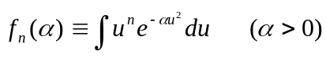

n | 0 | 1 | 2 | 3 | 4 | 5
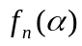 | 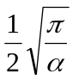 | 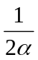 | 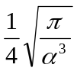 | 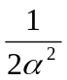 | 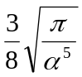 | 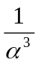

Value of Error Function
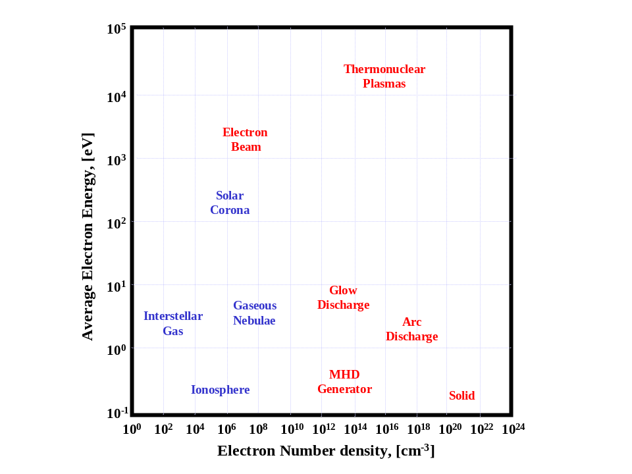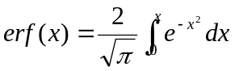
x | erf(x)
0 | 0
0.2 | 0.2227
0.4 | 0.4284
0.6 | 0.6039
0.8 | 0.7421
1.0 | 0.8427
1.2 | 0.9103
1.4 | 0.9523
1.6 | 0.9763
1.8 | 0.9891
2.0 | 0.9953
2.2 | 0.9981
2.4 | 0.9993
2.6 | 0.9998
2.8 | 0.9999

